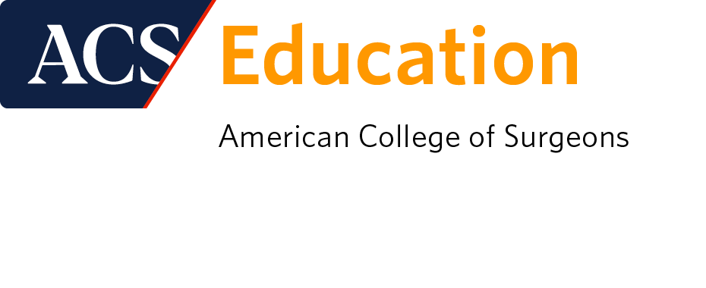

EVALUATION FORM

Missouri Chapter Annual Professional Meeting
April 29 – 30, 2023 | Lake Ozark, Missouri

To receive a CME Certificate: Please bring this completed form to: Registration Desk

Hours of Operation: April 29 8:00am – 5:00 pm | April 30 8:00 am – 12:00 pm

Name  (Please Print) |  | Are you a member of the American College of Surgeons? | ☐ YES ☐ NO
Email address |  | ACS Membership ID (required)  Credits will not post to your ACS transcript inside the MyCME portal if ID is not provided
Number of Years in Practice (Optional) |  | State(s) you are licensed

AMA PRA Category 1 Credits™

The American College of Surgeons designates this live activity for a maximum of 15.00 AMA PRA Category 1 Credits™.

Physicians should claim only the credit commensurate with the extent of their participation in the activity.

Of the AMA PRA Category 1 Credits™ listed above, a maximum of 1.00 credits meet the requirements for Cancer.
Of the AMA PRA Category 1 Credits™ listed above, a maximum of 1.00 credits meet the requirements for Bariatric Surgery.
Of the AMA PRA Category 1 Credits™ listed above, a maximum of 4.00 credits meet the requirements for Trauma.

*The content of this activity may meet certain mandates of regulatory bodies. Please note that ACS has not and does not verify the content for such mandates with any regulatory body. Individual physicians are responsible for verifying the content satisfies such requirements.

Learning Objectives:
At the conclusion of this activity, the learner should be able to...
- Describe approaches to trauma care for the multiply-injured patient.
- Understand and learn to apply the fundamental ethical considerations in surgical care
- Identify areas of improvement in rural hospital systems.
- Analyze the impact of surgical techniques and treatment on patient outcomes
- Address care of bariatric patients in community settings
- Evaluate and prepare cancer patients for surgical intervention
- Recognize and manage general surgery emergencies with limited resources
- Evaluate and address difficult cases from the emergency

As a participant of this educational activity, I am claiming _________________ hours of CME Credit.

Number of __Cancer_________ hours claimed: _____________

Number of __Bariatric Surgery_ hours claimed: _____________

Number of __Trauma________ hours claimed: _____________

*Note: 15 minutes of session attendance = 0.25 AMA PRA Category 1 Credits™

Please check the appropriate box.
 | Excellent | Very Good | Good | Fair | Poor
- Overall, how would you rate this educational activity? | ☐ 5 | ☐ 4 | ☐ 3 | ☐ 2 | ☐ 1
 | Strongly Agree | Agree | Neutral | Disagree | Strongly Disagree
- Program topics and content met the stated objectives. | ☐ 5 | ☐ 4 | ☐ 3 | ☐ 2 | ☐ 1
- Content was relevant to my educational needs. | ☐ 5 | ☐ 4 | ☐ 3 | ☐ 2 | ☐ 1
- Educational format was conducive to learning. | ☐ 5 | ☐ 4 | ☐ 3 | ☐ 2 | ☐ 1
- This activity has improved my competence. | ☐ 5 | ☐ 4 | ☐ 3 | ☐ 2 | ☐ 1
- This activity will improve my performance. | ☐ 5 | ☐ 4 | ☐ 3 | ☐ 2 | ☐ 1
- This activity will enhance my communication skills. | ☐ 5 | ☐ 4 | ☐ 3 | ☐ 2 | ☐ 1
- This activity will improve patient outcomes. | ☐ 5 | ☐ 4 | ☐ 3 | ☐ 2 | ☐ 1
- This activity will improve processes of care and/or healthcare system performance. | ☐ 5 | ☐ 4 | ☐ 3 | ☐ 2 | ☐ 1
- Program was free of commercial bias. | ☐ Yes | ☐ No
If “no”, please explain instances of commercial bias:

- How could this educational activity be enhanced?

- List a minimum of two things you are going to change as a result of what you have learned.
1.

2.

- Describe the barriers anticipated when implementing the above changes.

- Do you have any suggestions for future topics?

- Additional Comments

