Missouri Chapter American College of Surgeons
2101 West Broadway
Suite 103, PMB 375
Columbia, MO 65203
E-mail: MissouriChapterACS@gmail.com

President Vice President Secretary/Treasurer
Jacob A. Quick, MD, FACS Andrew A. Wheeler, MD, FACS Sekhar Dharmarajan, MD FACS
quickja@health.missouri.edu wheeleraa@health.missouri.edu DharmarajanSekhar@gmail.com

January 15, 2023

The Missouri Chapter of the American College of Surgeons is seeking commercial promotion and support opportunities for our annual meeting on April 29-30, 2023, at Camden on the Lake in Lake Ozark, Missouri. Fellows of the American College of Surgeons from academic centers and private practice come to this meeting to update their fund of knowledge and renew friendships. Surgical residents from Washington University in St. Louis, St. Louis University, the University of Missouri-Columbia, and the University of Missouri-Kansas City also attend and present the results of their research.

We can only present this important educational and networking opportunity with the assistance and attendance of our supporters. We are offering two levels of support.

Exhibitors will have a highly visible table reserved for their display as well as ample time before, during, and after the meeting for interaction with meeting participants. Exhibit tables cost $1,000.00 for the entire meeting.

Educational Grant Supporters will receive an acknowledgement in the meeting program book and from the podium at the beginning of the meeting each day.

If you are interested in becoming a supporter, please return the “Intent to Support Form”. The MOACS is tax exempt and the tax ID is 43-1038532. We look forward to an exciting program at this year’s meeting and appreciate your consideration of supporting our educational activities.

Visit our website at www.moacs.org for additional information.

Sincerely,
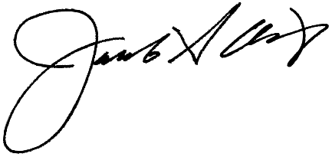
Jacob A. Quick, MD, FACS
President

